hazem************************ AWR IN ORACLE ************************

*************** take manual snapshot************

EXEC DBMS_WORKLOAD_REPOSITORY.create_snapshot;



 Check the snapshots(whether new one is created or not )

select snap_id,BEGIN_INTERVAL_TIME,END_INTERVAL_TIME from dba_hist_snapshot where BEGIN_INTERVAL_TIME > systimestamp -1 order by BEGIN_INTERVAL_TIME desc;

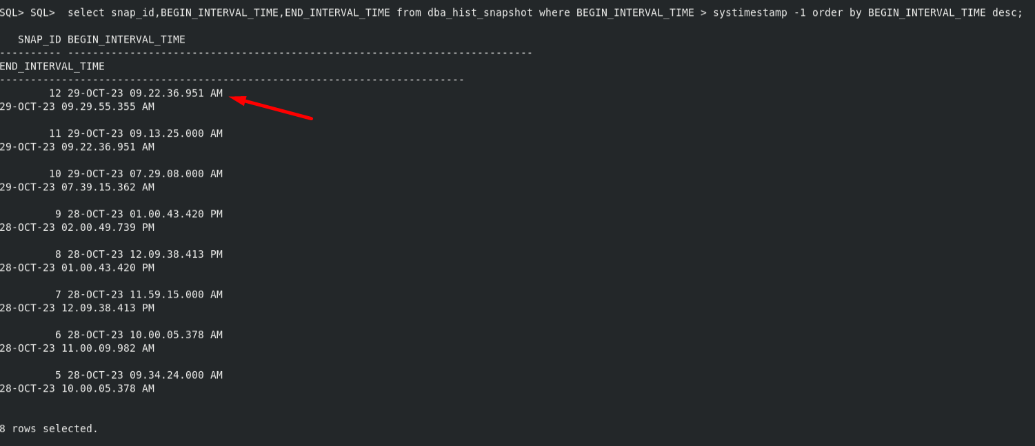

The snap_id

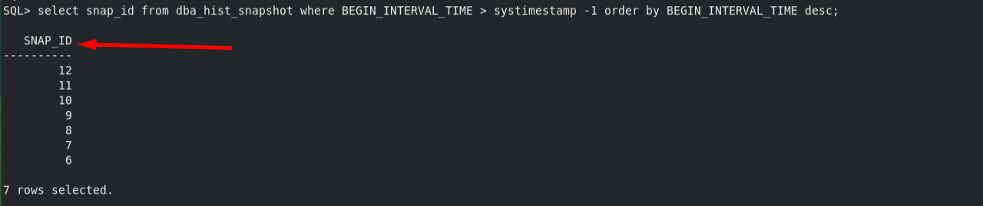

Specify the begin and end snapshot ids :

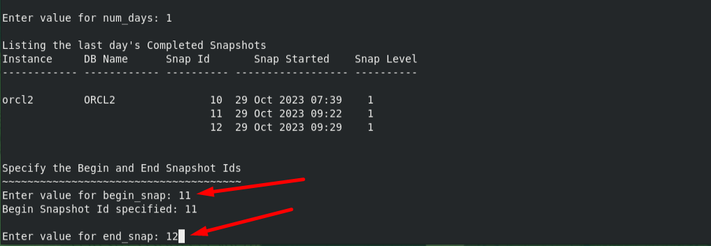

***

***************

*************** AWR *******************

**********************************************************

The Automatic Workload Repository (AWR) collects and maintains statistics of the database.

We can generate awr report for a particular time frame in the past using the script **awrrpt.sql ( located under $ORACLE_HOME/rdbms/admin)**

@$ORACLE_HOME/rdbms/admin/awrrpt.sql

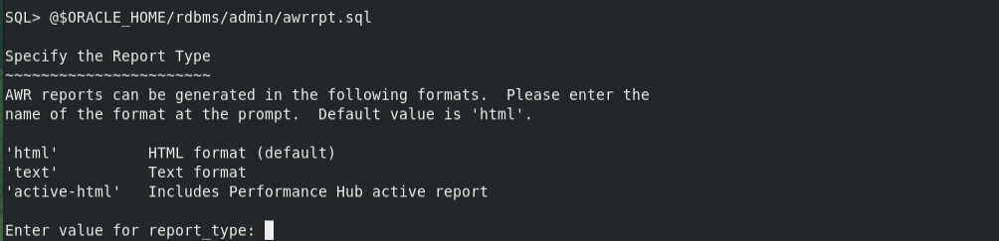

Press enter

Specify the number of days :

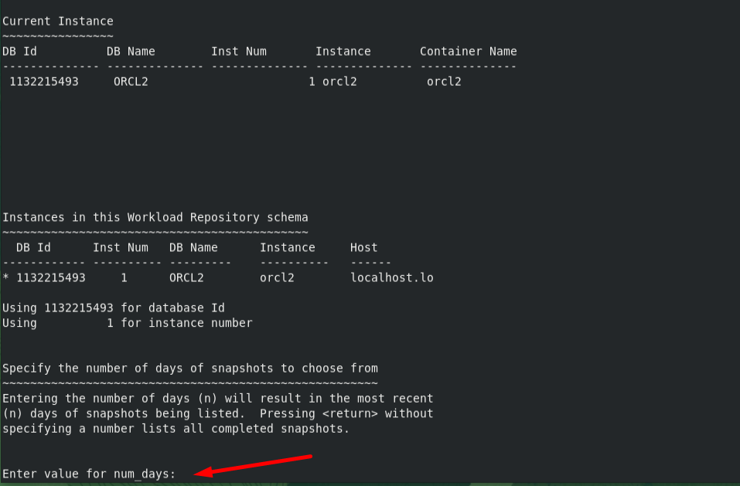

Specify the Report name :

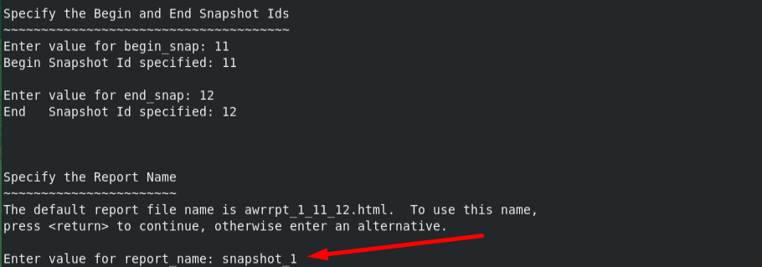

The report written to snapshot_1.html successfully:

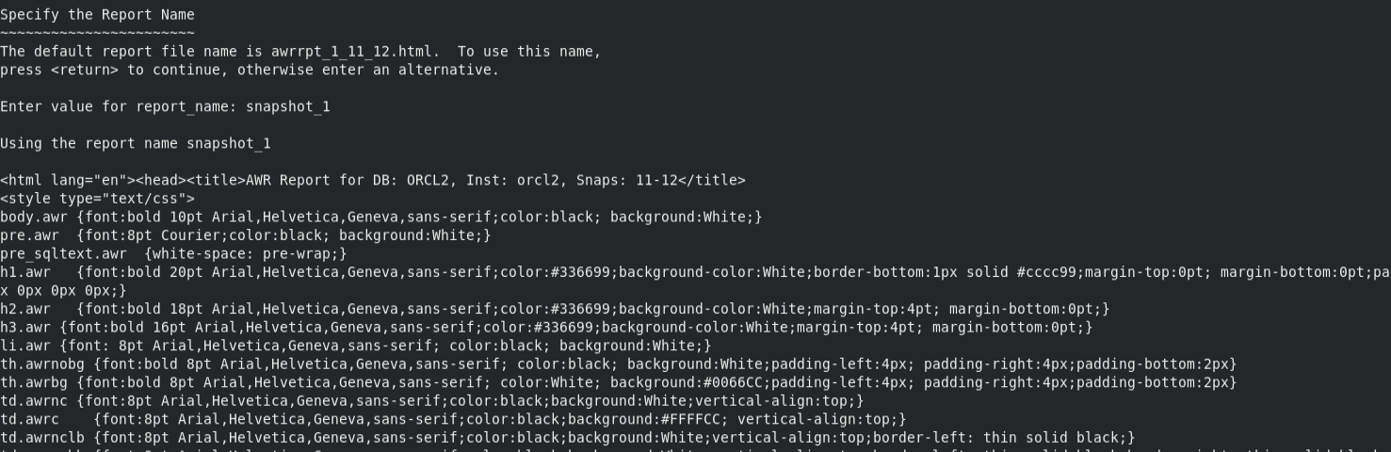





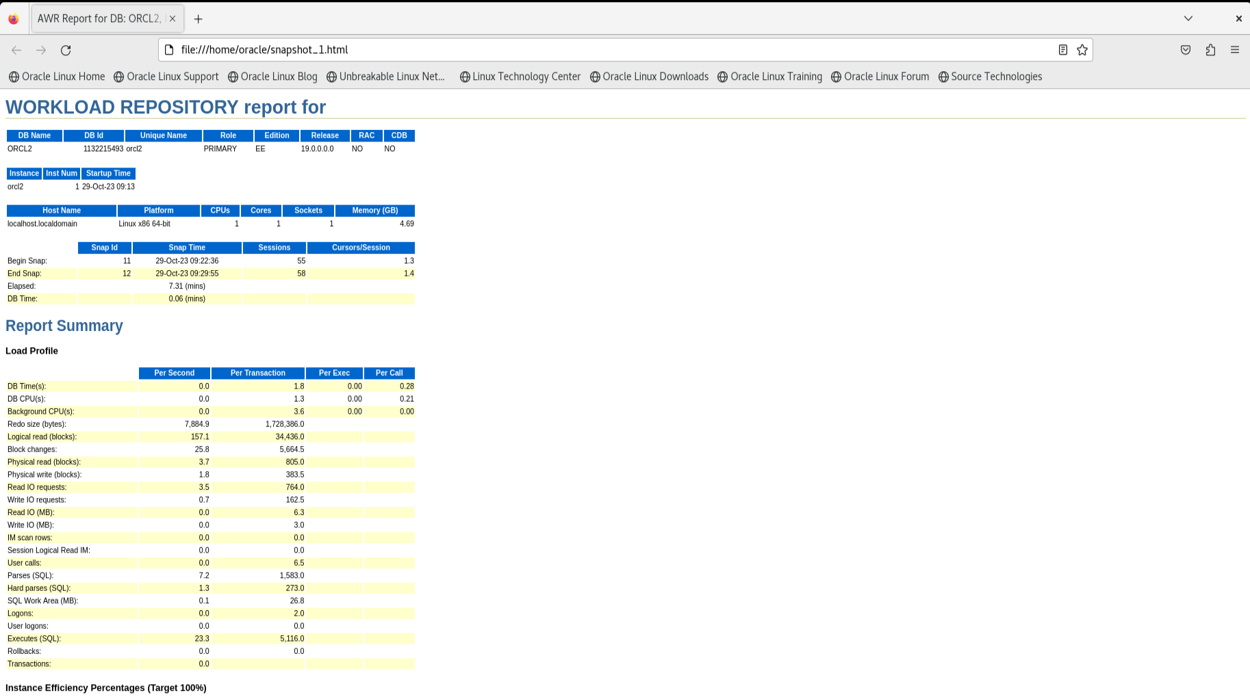

****************************** end *************************************

For rac databases, the script awrrpt.sql script need to be run again each instance.